Simulation of Vehicle-to-Vehicle (V2V)
Communication using 5G and
Latency Analysis
Report submitted to GITAM (Deemed to be University) as a partial fulfillment
of the requirements for the award of the Degree of Bachelor of Technology in
(ECAIML)

DEPARTMENT OF ELECTRICAL, ELECTRONICS AND COMMUNICATION ENGINEERING
GITAM SCHOOL OF TECHNOLOGY
GITAM (DEEMED TO BE UNIVERSITY)
BENGALURU -561203
NOV 2025

Name: C BHAVANI SHANKAR, SOMNATH K, SAI TEJA K
Regd.No .: BU22EECE0100040, BU22EECE0100238, BU22EECE0100427
DEPARTMENT OF ELECTRICAL, ELECTRONICS AND COMMUNICATION ENGINEERING
GITAM SCHOOL OF TECHNOLOGY
GITAM (DEEMED TO BE UNIVERSITY)
BENGALURU -561203
NOV 2025

DECLARATION

I/We declare that the project work contained in this report is original and it has been done by me under the guidance of my project guide.

Name: C BHAVANI SHANKAR (BU22EECE0100040)
SOMNATH K(BU22EECE0100238)
SAI TEJA K(BU22EECE0100427)

Date:

Signature of the Student

01

Department of Electrical, Electronics and Communication Engineering GITAM School of Technology, Bengaluru-561203



CERTIFICATE

This is to certify that C BHAVANI SHANKAR, SOMNATH K, SAI TEJA K bearing BU22EECE0100040, BU22EECE0100238, BU22EECE0100427
has satisfactorily completed Mini Project Entitled in partial fulfillment of the requirements as prescribed by University for VIIth semester, Bachelor of Technology in “Electronics and Communication Engineering” and submitted this report during the academic year 2025-2026.

[Signature of the Guide] [Signature of HOD]

02
Table of contents
DEPARTMENT OF ELECTRICAL, ELECTRONICS AND COMMUNICATION ENGINEERING
GITAM SCHOOL OF TECHNOLOGY
GITAM (DEEMED TO BE UNIVERSITY)
BENGALURU -561203
NOV 2025

Chapter 1: Introduction 1
  - Overview of the problem statement 1
  - Objectives and goals 1
Chapter 2 : Literature Review 2
Chapter 3 : Strategic Analysis and Problem Definition 3
  - SWOT Analysis 3
  - Project Plan - GANTT Chart 3
  - Refinement of problem statement 3
Chapter 4 : Methodology 4
  - Description of the approach 4
  - Tools and techniques utilized 4
  - Design considerations 4
Chapter 5 : Implementation5
  - Description of how the project was executed 5
  - Challenges faced and solutions implemented 5
Chapter 6: Results 6
  - outcome 6
  - Interpretation of results 6
  - Comparison with existing technologies 6
Chapter 7: Conclusion 7
Chapter 8 : Future Work 8
References 9

03

Chapter 1: Introduction

  - Overview of the Problem Statement

The rapid growth of intelligent transportation systems (ITS) has emphasized the need for fast, reliable, and low-latency communication between vehicles on the road. Vehicle-to-Vehicle (V2V) communication allows cars to exchange essential information such as speed, position, braking status, and road conditions. This communication reduces accidents, improves traffic flow, and assists in autonomous driving.
Traditional wireless communication systems such as DSRC (Dedicated Short-Range Communications) and LTE face limitations in terms of latency, scalability, mobility support, and reliability. With vehicles travelling at high speeds, even a slight delay in receiving critical safety messages can result in collisions.
5G technology, equipped with Ultra-Reliable Low-Latency Communication (URLLC), massive MIMO, and network slicing, offers a promising solution. Its ability to support millisecond-level latency and high data throughput makes it ideal for real-time V2V communication.
This project focuses on simulating V2V communication using 5G networks and analyzing latency performance under different scenarios.

  - Objectives and Goals

Primary Objectives

- To simulate V2V communication using a 5G network framework.
- To measure and analyze latency under different traffic and network conditions.
- To evaluate the performance of 5G-based V2V communication compared with traditional systems.
Secondary Goals
- To understand the role of 5G URLLC in enhancing V2V reliability.
- To simulate realistic vehicular movement and communication patterns.
- To examine network behavior during congestion and high-speed mobility.
- To develop visual results (graphs and metrics) of latency, throughput, and packet delivery ratios.
04
Chapter 2: Literature Review

- Vehicle-to-Vehicle (V2V) communication is a fundamental technology within Intelligent Transportation Systems (ITS) that enables direct wireless data exchange between vehicles. Through V2V communication, vehicles can share real-time information such as speed, position, acceleration, braking status, and hazard alerts, allowing drivers and automated systems to react proactively to potential dangers. This capability significantly contributes to reducing road accidents, improving traffic flow efficiency, and enabling cooperative driving applications.
- Initial research in V2V communication primarily relied on Dedicated Short Range Communication (DSRC) based on the IEEE 802.11p standard. Although DSRC provided low-latency communication suitable for basic safety messages, various studies revealed its performance limitations in dense vehicular environments. As the number of vehicles increases, channel contention leads to increased packet collisions, reduced Packet Delivery Ratio (PDR), and higher communication delays. Moreover, DSRC lacks effective scalability and struggles to maintain stable performance in dynamic, high-mobility conditions, limiting its suitability for advanced applications such as autonomous driving and real-time cooperative systems.
- To overcome the shortcomings of DSRC, LTE-based V2V communication was introduced as a cellular alternative. LTE-V2V improved communication reliability and coverage by integrating with cellular network infrastructure. However, research indicates that LTE-V2V still falls short in meeting the stringent requirements of next-generation vehicular applications. In particular, LTE struggles to consistently achieve ultra-low latency in the range of 1–10 milliseconds, which is essential for applications such as cooperative collision avoidance, emergency braking coordination, and autonomous vehicle platooning. Performance degradation in high-speed scenarios and congested urban environments further limits its effectiveness.
- In recent years, 5G-based V2V communication has emerged as the most promising solution for future vehicular networks. 5G introduces significant advancements such as Ultra-Reliable Low-Latency Communication (URLLC), enhanced scheduling techniques, massive bandwidth availability, and improved interference management. These features enable highly reliable data transmission with consistently low latency, even in scenarios involving dense traffic and high vehicle mobility. Research demonstrates that 5G maintains stable communication links under rapidly changing network conditions, making it ideal for time-critical vehicular safety applications.
05

- Several studies highlight that 5G V2V communication significantly outperforms both DSRC and LTE in terms of latency, reliability, and network stability. While DSRC and LTE often exhibit fluctuating delay and packet loss under heavy load, 5G-based systems show more consistent performance, ensuring faster message delivery and improved reaction times in emergency scenarios. This makes 5G particularly suitable for applications such as collision warning systems, adaptive cruise control, lane change assistance, and cooperative driving strategies.
- Research also emphasizes that effective V2V systems must consider realistic mobility conditions, vehicle density variations, and environmental factors. High relative speeds, frequent topology changes, and unpredictable vehicle behavior introduce significant challenges in maintaining stable communication links. 5G technologies address these challenges through advanced resource allocation mechanisms and optimized scheduling strategies, allowing for better handling of network congestion and interference.
- The current project builds upon these established research findings by analyzing V2V communication performance under 5G conditions. The study focuses on evaluating latency behavior, packet delivery performance, and safety implications in varying mobility scenarios. By examining how communication delay responds to changes in vehicle positioning and movement, the project highlights the importance of reliable low-latency 5G V2V communication in ensuring effective vehicle coordination and improved road safety.
- Overall, existing literature strongly supports the transition from DSRC and LTE-based systems to 5G V2V communication for next-generation transportation. The enhanced capabilities of 5G provide a robust framework for supporting safety-critical applications, enabling real-time decision-making and creating a foundation for fully autonomous and intelligent vehicle networks.

06

2.1 Conventional Wireless Communication

Before the deployment of 5G, V2V and V2I communication mainly relied on Dedicated Short-Range Communications (DSRC) and LTE-V technologies.
- DSRC operates in the 5.9 GHz band and supports low-latency communication but suffers from limited range and scalability.
- LTE-V improved mobility support and coverage but could not achieve the ultra-low latency (<10 ms) required for real-time safety applications.
Both methods face challenges in high-density traffic due to interference and limited bandwidth efficiency.

2.2 Limitations of LTE/DSRC Systems

Although effective for basic vehicular networking, DSRC and LTE are not well suited for autonomous vehicle coordination or massive sensor data exchange.
Major limitations include:
- High latency during handovers and congestion.
- Insufficient bandwidth for large data transfer.
- Limited reliability in non-line-of-sight (NLOS) conditions.
These issues necessitate the transition to 5G New Radio (NR), which supports ultra-reliable low-latency communication (URLLC).

2.3 5G and V2X Communication

5G provides enhanced Mobile Broadband (eMBB), massive Machine-Type Communication (mMTC), and URLLC — enabling fast, reliable data transfer among vehicles and infrastructure. MATLAB’s 5G Toolbox, Vehicle Dynamics Blockset, and Simulink are used to model and analyze 5G-based V2X networks.
5G V2X allows:
- Real-time communication between vehicles (V2V).
- Infrastructure coordination via roadside units (V2I).
- Dynamic latency monitoring and adaptive resource allocation.

07

2.4 Comparative Studies

Studies from MathWorks, Qualcomm, and ETSI show that 5G significantly reduces latency and improves packet delivery ratio compared to LTE and DSRC.
MATLAB simulations confirm that end-to-end latency can reach below 10 ms under optimized network parameters, making 5G ideal for safety-critical applications such as collision avoidance and platooning

Chapter 3: Strategic Analysis and Problem Definition
Strengths
- Utilises 5G New Radio (NR) technology, which supports ultra-low latency (below 10 ms) and high reliability, making it highly suitable for safety-critical applications such as collision avoidance, emergency braking alerts, and cooperative driving systems.
- Provides a controlled and flexible simulation environment where V2V communication behaviour can be analysed without the risks and costs associated with real-world field testing.
- MATLAB allows precise modelling of channel conditions, mobility patterns, interference, packet loss, and retransmission mechanisms, enabling realistic performance evaluation.
- Supports comprehensive analysis of multiple performance metrics such as latency, Packet Delivery Ratio (PDR), jitter, throughput, and safety risk, thereby enhancing the technical depth and credibility of the study.
- The architecture is scalable and adaptable to different road scenarios including urban intersections, highways, and dense traffic environments, making it suitable for broader research applications.
- Enables repeatable experimentation under identical conditions, improving result consistency and allowing for accurate comparison between communication configurations.
- Provides valuable insights into how vehicle spacing and mobility affect communication performance, which is essential for optimizing real-time vehicular safety systems.
08

Weaknesses
- The study relies entirely on simulation results, and therefore may not fully represent the unpredictable behaviour of real-world 5G network deployments.
- Real-time testing using actual roadside units and vehicles is not performed, limiting practical validation of the results.
- Integration of mobility models, path loss modelling, interference algorithms, and statistical analysis increases overall system complexity.
- Simplified assumptions in channel modelling may not capture the full effects of obstacles, terrain variations, or complex signal propagation.
- Limited representation of mmWave propagation and beamforming effects in high-speed mobility scenarios reduces accuracy for certain advanced use cases.
- Hardware-level constraints such as processing delays, antenna alignment, and device imperfections are not fully considered.
- Scenario-based modelling may not fully reflect highly dynamic and unpredictable real traffic behaviour.

Opportunities
- The rapid expansion of 5G-based Intelligent Transportation Systems (ITS) creates strong potential for extending this research into real-world applications.
- Opportunity to integrate Artificial Intelligence and Machine Learning techniques for predictive congestion management, dynamic routing, and intelligent collision avoidance systems.
- Potential to extend the simulation framework to include autonomous driving functionalities such as cooperative lane merging and real-time decision support.
- Can be enhanced to support hybrid simulations combining 5G communication with radar and LiDAR sensing for perception-based vehicle environments.
- The simulation model can be scaled to analyse large networks with hundreds of vehicles to study future smart city traffic ecosystems.
- Opens possibilities for developing adaptive resource allocation algorithms to improve communication efficiency under varying traffic loads.
- Provides a foundation for future research into edge computing-based safety and traffic control systems.
- the simulation framework can be extended to support integration with smart traffic infrastructure, enabling coordinated vehicle-to-traffic-signal communication for adaptive signal control and optimized traffic flow management.

09

Threats
- Continuous evolution of 3GPP standards may cause model incompatibility if updates are not regularly incorporated.
- Cybersecurity threats such as spoofing, jamming, denial-of-service attacks, and data manipulation can severely impact V2V communication reliability.
- Network overload and spectrum congestion in real deployments may lead to delayed message delivery or packet drops.
- Environmental factors such as weather disturbances, signal obstruction, and infrastructure limitations can reduce real-world performance.
- Rapid technological advancements may make the implemented simulation approach less relevant over time.
- Hardware limitations and inconsistent network coverage in rural or remote areas may hinder large-scale implementation.
- Regulatory restrictions and spectrum allocation challenges may delay practical deployment.

3.3 Project Plan – Gantt Chart
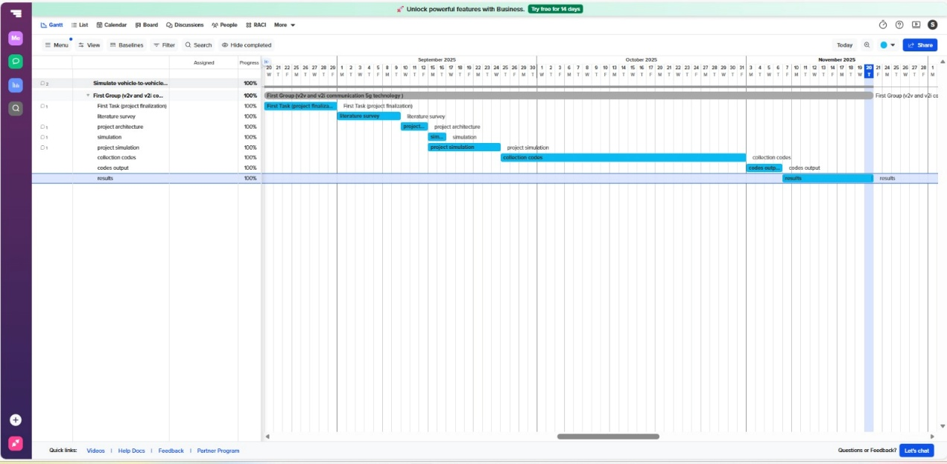

10

Refinement of Problem Statement

Original Problem
- Simulate V2V communication using 5G and analyze latency.

Refined Problem Statement
- Existing vehicular communication technologies such as DSRC and LTE-V2V have been widely used to support basic safety applications; however, they are unable to consistently meet the ultra-low latency, high reliability, and real-time responsiveness required for modern autonomous driving and safety-critical vehicular systems. These technologies suffer from increased delay, packet loss, and unstable communication performance under high vehicle density, fast mobility, and congested traffic environments. As a result, they fail to provide the level of performance necessary for advanced applications such as collision avoidance, cooperative braking, lane change coordination, and accident prevention systems.
- To overcome these limitations, this project focuses on the design and simulation of a 5G-enabled Vehicle-to-Vehicle (V2V) communication framework using MATLAB. The simulation model aims to evaluate how 5G technology can improve communication efficiency, reliability, and responsiveness in vehicular networks. The study emphasizes the analysis of critical performance parameters such as end-to-end latency, Packet Delivery Ratio (PDR), throughput, jitter, and safety risk metrics under varying traffic densities, mobility conditions, and inter-vehicle distances.
- The proposed framework also examines how changes in vehicle positioning, network load, and traffic congestion influence communication behaviour. By simulating realistic traffic scenarios, the project seeks to understand the relationship between communication performance and vehicle mobility patterns, thereby providing insight into the suitability of 5G V2V systems for real-world deployment.
- Furthermore, the refined problem addresses the need for an efficient communication model capable of supporting Intelligent Transportation Systems (ITS) and next-generation autonomous vehicles. The study aims to demonstrate that 5G NR technology can provide a scalable and robust solution for real-time vehicular communication, ensuring rapid information exchange and improved road safety

11
Chapter 4 : Methodology
4.1 Description of the Approach
The methodology follows a simulation-driven approach to analyze the performance of 5G-based V2V communication. The complete workflow is divided into sequential and iterative steps:
- Scenario Initialization
  - Define road layout, number of vehicles, mobility patterns, and traffic density.
  - Use MATLAB Vehicle Dynamics Toolbox for vehicle movement modeling.
- Network Configuration
  - Setup 5G NR communication parameters such as numerology, subcarrier spacing, bandwidth, slot configuration, and sidelink settings.
  - Configure both V2V channels including path loss, fading, and Doppler effects.
- Message Exchange Simulation
  - Implement periodic safety messages (BSM/CAM-like packets).
  - Simulate real-time communication between vehicles and between vehicles and RSU/gNB.
  - Capture message time-stamps for latency and throughput analysis.
- Performance Evaluation
  - Compute latency, jitter, packet delivery ratio (PDR), throughput, and collision-risk metrics.
  - Visualize results using heatmaps, latency matrices, mobility plots, and risk curves.
- Comparison and Validation
  - Compare 5G results with baseline LTE/DSRC where applicable.
  - Validate results against predefined use cases and test cases (TC-01 to TC-08).
    - This structured approach ensures systematic development, simulation, evaluation, and refinement of the V2X communication model.

12
4.2 Tools and Techniques Utilized

MATLAB R2023 / R2024
- Primary platform used for the complete design, execution, and analysis of the 5G V2V simulation framework.
- Provides an integrated environment for numerical computation, matrix processing, simulation control, and high-quality visualisation.
- Supports efficient handling of large datasets, Monte-Carlo runs, and iterative performance evaluation.
- Enables seamless integration of custom PHY-layer logic, traffic models, and performance metrics without external dependencies.

MATLAB 5G Toolbox
- Used for modelling 5G NR physical layer concepts such as numerology, slot structure, and sidelink configuration principles.
- Supports accurate representation of URLLC behaviour, slot timing, and HARQ mechanisms.
- Facilitates the conceptual modelling of 5G NR sidelink transmission and resource allocation strategies.
- Helps align the simulation with real-world 3GPP-compliant 5G NR standards.

MATLAB Vehicle Dynamics / Automated Driving Toolbox
- Used to generate realistic vehicle mobility patterns and spatial positioning behaviour.
- Enables simulation of varied traffic scenarios such as highways, intersections, and dense urban environments.
- Helps model vehicle movement, relative distance changes, and dynamic topology variation over time.
- Enhances realism in collision-risk detection and safety event analysis.

13

MATLAB Communications Toolbox
- Used for accurate wireless channel modelling, including noise, fading, interference, and link performance.
- Supports modelling of pathloss, Doppler effects due to mobility, and channel variability.
- Assists in SINR calculation and link-quality evaluation.
- Enables realistic representation of packet-level failures and retransmission behaviour.

Parallel Computing Toolbox
- Used to accelerate Monte-Carlo simulation runs by distributing computations across multiple cores.
- Enables faster execution of large-scale simulations with multiple vehicles and long durations.
- Improves efficiency when performing repeated experiments with different random seeds.
- Reduces total simulation time while maintaining computational accuracy.

Statistics and Machine Learning Toolbox
- Used for statistical modelling of Rayleigh fading, Gaussian noise, and random traffic variations.
- Supports probability distribution functions for jitter modelling and PER estimation.
- Enables advanced analysis of latency distributions, variance, and percentile computation (P50, P90, P99).
- Provides potential for integrating predictive models for congestion estimation and safety risk forecasting between vehicles.

CSV Dataset Processing Tools
- Used to import real-world traffic and environmental metadata.
- Provides data such as congestion level, weather condition, traffic volume, and average speed.
- These parameters are used to dynamically adjust latency, noise, and interference levels.
14

Summary of Technical Contribution
The combination of these MATLAB toolkits provides a powerful and flexible simulation ecosystem that integrates physical-layer modelling, mobility behaviour, statistical analysis, and high-quality visualisation. This multi-tool approach ensures that the 5G V2V simulation accurately reflects real-world vehicular communication scenarios while maintaining computational efficiency and analytical depth. It also allows future scalability toward artificial intelligence integration, real-time optimisation, and intelligent traffic management systems.

System Architecture
Configuration Block
The configuration block serves as the core control unit of the entire simulation framework. It defines and centralizes all system parameters that govern the behaviour of the V2V network and wireless channel. These parameters include the dataset path, number of vehicles, simulation duration, packet generation rate, 5G numerology (μ), slot duration, number of resource blocks (RBs), pathloss exponent, transmission power, noise floor, and ARQ retry limits.
In addition, it includes safety-related parameters such as collision distance threshold and mobility step duration. This centralized structure allows flexible modification of simulation conditions without altering the core logic, making the system highly configurable and scalable for different test scenarios.

Dataset Integration
The simulation integrates a real-world traffic dataset in CSV format to enhance realism. The dataset provides contextual parameters such as area name, road segment, weather conditions, congestion level, traffic volume, average vehicle speed, and incident reports. These parameters dynamically influence network performance.
These values are used to scale communication behaviour as follows:
15
- Base latency is adjusted using a congestion multiplier to simulate delay increase in heavy traffic.
- Noise factor is modified based on weather conditions (rain, fog), introducing environmental degradation effects.
- Incident-based noise adds random delay variations to simulate sudden disruptions or abnormal traffic patterns.
This dataset-driven approach ensures that the simulation reflects more realistic urban traffic behaviour instead of relying on fixed theoretical assumptions.

Vehicle Initialization and Mobility Model
Five vehicles are placed at predefined positions to maintain consistent topology and allow easy visual interpretation of network links. These positions form a structured layout resembling realistic road spacing between vehicles.
Vehicle motion is modelled using small sinusoidal displacement patterns in both horizontal and vertical directions. This creates continuous variation in inter-vehicle distance, resulting in dynamic changes in pathloss, received power, and SINR levels. Such movement simulates realistic vehicle behaviour where relative positioning constantly evolves, directly influencing communication performance over time.
This simplistic but effective mobility model allows the study of how communication quality fluctuates with changes in distance and relative orientation.

Safety Event Detection
Safety events are detected using a distance-based threshold mechanism. If the distance between any two vehicles falls below 15 meters, the system registers this as a safety-critical condition. This represents a high-risk proximity scenario where collision avoidance systems would typically be activated.
To avoid redundant counting, once two vehicles are already marked as close, the event is not repeatedly counted until they move apart and re-enter the danger zone. This approach helps estimate genuine collision risk rather than exaggerating repeated detections.
These detected events are used to calculate collision-risk trends and contribute to the Safety Risk Metric for overall system evaluation.
16
Packet Transmission Pipeline
The packet transmission process represents the core communication workflow. For each generated V2V packet, the following sequential operations are performed:
- Packet generation time is mapped to a corresponding 5G NR slot index based on the selected numerology (μ).
- Each transmitter randomly selects a resource block from the available RB pool, simulating autonomous sidelink scheduling.
- Current inter-vehicle distances are used to generate a pathloss matrix for all transmitter-receiver pairs.
- For each TX–RX link, Rayleigh fading is applied to model fast wireless channel variations.
- Received signal power, background noise, and co-channel interference from vehicles using the same RB are calculated.
- Signal-to-Interference-plus-Noise Ratio (SINR) is computed in both linear and decibel scales.
- SINR is mapped to Packet Error Rate (PER) using a sigmoid-based probabilistic model.
- ARQ retransmissions are performed up to the specified retry limit if packet loss occurs.
- If a transmission succeeds, the observed latency is recorded as the sum of baseline delay, HARQ slot delay, and random jitter.
- If all attempts fail, the packet is marked as dropped and contributes to PDR degradation.
- Transmission success probability is dynamically adjusted based on instantaneous channel quality and interference conditions.
This pipeline closely mimics real V2V communication behaviour where channel quality, interference, and retransmissions determine final packet delivery.

17

- Performance Metrics Evaluation
- The simulation computes extensive performance metrics for detailed analysis:
- Per Vehicle Metrics
  - Mean latency representing average communication delay.
  - Jitter indicating variability in delay.
  - Packet Delivery Ratio (PDR) representing reliability.
  - Per Run Metrics
- Total safety events detected during the simulation.
- Latency percentiles (P50, P90, P99) to reflect URLLC suitability.
- Aggregated Metrics Across Runs
- Mean and standard deviation of latency, jitter, and PDR across all simulation runs.
- Stability analysis based on variation of these values.
- These metrics provide both micro-level and system-level insights into
- communication performance.

Monte-Carlo Simulation Design
The simulation uses a Monte-Carlo approach, executing multiple runs with different random seeds to capture randomness in fading, interference, resource allocation, and mobility behaviour. This provides a statistically reliable estimate of system performance rather than relying on a single deterministic outcome.
By averaging results across multiple runs, the system evaluates the robustness, stability, and consistency of the 5G V2V communication model. This approach helps in identifying worst-case and best-case performance scenarios and improves the credibility of the results.

Overall System Flow
The complete workflow can be summarised as:
Configuration Setup → Dataset Processing → Vehicle Initialization → Mobility Update → Safety Detection → Packet Transmission → Metric Calculation → Monte-Carlo Aggregation → Result Visualization
This layered architecture ensures modularity, logical clarity, and systematic evaluation of the 5G V2V communication system.

18

Techniques Utilized

5G NR Sidelink Communication (PC5 Interface)
- The 5G NR sidelink enables direct V2V communication without involving the base station, eliminating routing delays. This allows vehicles to instantly exchange safety messages like collision alerts, speed changes, or lane shifts. The PC5 interface offers faster scheduling, efficient resource allocation, and better interference management than LTE-V2X, achieving ultra-low latency for real-time data sharing

5G NR Uu Interface (V2I via gNodeB)
The Uu interface handles V2I communication through the 5G base station (gNodeB) connecting vehicles with RSUs, cloud servers, and traffic systems. It supports high-bandwidth and long-range communication, enabling real-time updates about traffic, hazards, and control signals using 5G’s low-latency and reliable link setup.

URLLC (Ultra-Reliable Low-Latency Communication)
URLLC ensures critical messages are delivered with latency under 10 ms and reliability above 99.999%. It uses mini-slot scheduling, short TTIs, and robust coding schemes to support mission-critical V2X use cases such as emergency braking and collision avoidance in autonomous driving scenarios.

Mobility Modeling
Mobility modeling recreates realistic vehicle movement, including speed, acceleration, lane changes, headway, and traffic density. It dynamically updates vehicle positions to compute path loss, Doppler effects, and communication range, ensuring accurate assessment of network performance under varying motion patterns.
- Latency and PDR Analysis
Latency measures transmission delay between sender and receiver timestamps, while Packet Delivery Ratio (PDR) indicates reliability by comparing received versus transmitted packets. MATLAB scripts compute latency profiles, PDR graphs, and heatmaps, helping evaluate 5G’s performance in high-speed, dense traffic scenarios.

19
- Risk Estimation Model
Risk estimation calculates collision probabilities using metrics like inter-vehicle distance, relative speed, braking rate, and latency. Time-to-collision formulas and delay variations help evaluate how stable 5G communication minimizes accident risk by improving awareness and reaction times among vehicles.

Vehicle Initialization and Mobility Model
- Five vehicles are placed at predefined positions to maintain consistent topology and allow easy visual interpretation of network links. These positions form a structured layout resembling realistic road spacing between vehicles.
- Vehicle motion is modelled using small sinusoidal displacement patterns in both horizontal and vertical directions. This creates continuous variation in inter-vehicle distance, resulting in dynamic changes in pathloss, received power, and SINR levels. Such movement simulates realistic vehicle behaviour where relative positioning constantly evolves, directly influencing communication performance over time.
- This simplistic but effective mobility model allows the study of how communication quality fluctuates with changes in distance and relative orientation.

Safety Event Detection
- Safety events are detected using a distance-based threshold mechanism. If the distance between any two vehicles falls below 15 meters, the system registers this as a safety-critical condition. This represents a high-risk proximity scenario where collision avoidance systems would typically be activated.
- To avoid redundant counting, once two vehicles are already marked as close, the event is not repeatedly counted until they move apart and re-enter the danger zone. This approach helps estimate genuine collision risk rather than exaggerating repeated detections.
- These detected events are used to calculate collision-risk trends and contribute to the Safety Risk Metric for overall system evaluation.

20

4.3 Design Considerations
Several design considerations were taken into account to ensure a realistic, robust, and technically authoritative simulation environment that closely reflects real-world 5G V2V communication behaviour.

Communication Reliability
- The Packet Delivery Ratio (PDR) was targeted to remain above 90% under both normal and congested traffic conditions to satisfy safety-critical communication requirements.
- Fading, stochastic noise, and Doppler effects were incorporated to realistically represent high-speed vehicular mobility and signal fluctuations.
- Interference modelling based on shared resource block allocation ensures realistic contention and collision scenarios, especially in dense traffic environments.
- ARQ-based retransmission mechanisms were introduced to improve packet success probability without drastically increasing end-to-end delay.
- Link stability was evaluated across time steps to ensure consistent communication quality.
- Reliability under varying inter-vehicle distances was analysed to capture distance-dependent degradation effects.
- Statistical averaging across Monte-Carlo runs was used to assess reliability consistency and robustness.

2. Ultra-Low Latency Requirements
- 5G NR parameters were carefully selected to support URLLC performance, including higher subcarrier spacing and μ-based numerology for reduced slot duration.
- Mini-slot scheduling mechanisms were conceptually implemented to minimize waiting time before transmission begins. 21
- System architecture was optimized to reduce processing latency, queuing delay, and channel access overhead.
- HARQ delay was directly linked to slot timing to accurately simulate retransmission delay behaviour.
- Latency percentiles (P50, P90, P99) were computed to evaluate compliance with real-time safety thresholds.
- Delay variation (jitter) was monitored to ensure stability in time-critical message delivery.
- Design focused on maintaining deterministic latency behaviour in worst-case scenarios.

3. Scenario Flexibility
- The simulation framework supports diverse traffic scenarios including urban intersections, highways, suburban roads, and mixed-density networks.
- Vehicle speed variations and random mobility patterns were introduced to test adaptability of the communication system.
- Configurable vehicle density enables evaluation under low-load and high-load conditions.
- Road layout flexibility allows testing of different spatial configurations and topology structures.
- Scalability testing ensures performance remains stable as vehicle count increases.
- Environmental uncertainty was integrated to mimic real-world driving unpredictability.
- Scenario switching allows rapid comparison of multiple traffic conditions.

22

4. Integration with Infrastructure
- Conceptual support for V2I communication is provided through virtual gNodeB and RSU entities.
- Infrastructure-based traffic coordination was considered for improving overall system efficiency.
- Handover mechanisms were evaluated to ensure continuous connectivity across coverage zones.
- Load balancing strategies were integrated to manage network strain during peak traffic.
- Infrastructure cooperation enhances centralized safety message distribution.
- Network control signaling was incorporated to reflect practical V2X system design.
- Support for future infrastructure expansion and smart city integration was considered.

5. Safety-Critical Application Support
- Communication parameters follow V2X safety standards such as 3GPP TR 22.886 and ETSI CAM specifications.
- Collision risk models account for both latency and real-time spatial separation between vehicles.
- Delay-sensitive applications such as emergency braking alerts, cooperative lane merging, and intersection collision warnings were prioritized.
- Failure scenario modelling was included to assess worst-case risk impact.
- Safety event detection algorithms monitor critical proximity violations.
- Safety reliability was evaluated through repeated simulations under varying conditions. 23
- Real-time risk adaptation mechanisms were incorporated in the simulation logic.
6. Expandability
- Modular architecture allows seamless integration of mmWave communication technologies.
- Directional beamforming and advanced antenna models can be introduced without major restructuring.
- Edge computing (MEC) integration enables decentralized data processing for faster decision-making.
- AI-based resource allocation and congestion prediction models can be implemented in future work.
- Scalability supports expansion toward large-scale vehicular networks.
- Design ensures compatibility with future 3GPP releases and evolving V2X standards.
- Supports integration with heterogeneous sensing technologies such as LiDAR and radar.

7. Additional System-Wide Design Enhancements
- Energy efficiency considerations were included to reflect real-world battery and power limitations.
- Bandwidth optimization ensures efficient utilization of limited communication resources.
- Error monitoring mechanisms help identify weak links in the communication chain.

24
- Visualization consistency was optimized for readability and academic presentation.
- Logging and debugging functionality support traceability and reproducibility of results.
- Parameter traceability allows systematic evaluation of design impact.
- Modular debugging enables isolation of subsystem performance issues.

8. Validation and Performance Assurance
- Cross-validation of performance metrics ensures simulation accuracy.
- Benchmark comparisons help measure performance consistency.
- Stress testing under worst-case congestion validates system resilience.
- Sensitivity analysis highlights parameter influence on performance.
- Performance boundaries help define safe operational limits.

Summary
The design considerations incorporated into the simulation framework ensure that it remains realistic, flexible, scalable, and technically aligned with real-world 5G V2V communication requirements. The system is capable of evaluating critical safety behaviour, supports future expansion, and maintains compliance with emerging vehicular communication standards.

25

Chapter 5 : Implementation
5.1 Description of How the Project Was Executed
    - The project was executed through a structured and systematic workflow designed to accurately model and analyze 5G-enabled V2V and V2I communication. The work began with a detailed requirement analysis, where limitations of existing technologies such as LTE and DSRC were studied, and the need for ultra-low latency and high reliability in vehicular environments was established. This analysis guided the design of the simulation architecture and ensured alignment with real-world V2X communication standards.
    - Following the requirement phase, a realistic vehicular scenario was developed using MATLAB’s Vehicle Dynamics Toolbox. Vehicles were assigned motion profiles, lane behaviors, and traffic densities to reflect highway and urban driving conditions. Parallel to this, the 5G NR communication layer was configured using MATLAB 5G Toolbox. Essential parameters—including numerology, sidelink PC5 configuration, Uu interface setup, URLLC features, and channel models—were defined to replicate authentic 5G behavior under high-mobility conditions.
Once the scenario and communication models were established, V2V and V2I message exchange was implemented. Vehicles were programmed to broadcast safety messages containing position, speed, and event-triggered information. MATLAB handled timestamping, routing, and queuing of packets, enabling accurate computation of latency, PDR, and throughput. The simulation was refined across multiple iterations to improve accuracy, reduce communication errors, and validate performance under different traffic conditions. Finally, all outputs—including latency matrices, heatmaps, distribution plots, and PDR graphs—were consolidated and documented to demonstrate the effectiveness of 5G supporting reliable and real-time vehicular communication. 26

5.2 Challenges Faced and Solutions Implemented
During the development and implementation of the 5G NR-based V2V and V2I simulation framework, several technical, architectural, and performance-related challenges were encountered. Each challenge required careful refinement of both modeling strategy and system configuration to ensure realistic and reliable results.

Challenge 1: Realistic Mobility Modeling
Problem:
Accurately representing real-world vehicle movement—such as varying speeds, lane changes, acceleration, braking behavior, stop-and-go traffic, and congestion—was essential for meaningful communication analysis. Manual motion models often produced overly simplified or unrealistic trajectories, which reduced the validity of latency and interference analysis.
Solution:
MATLAB’s Vehicle Dynamics / Automated Driving Toolbox was integrated to generate realistic vehicle trajectories with controlled acceleration, deceleration, lane changes, and route-following behavior. Additionally:
- Parameterized mobility profiles were created for urban, highway, and congested scenarios.
- Dynamic speed variations were introduced to reflect driver behavior.
27
- Mobility synchronization with communication time-steps ensured that channel updates accurately reflected spatial changes.
This enhancement significantly improved the fidelity of the mobility model and ensured more accurate evaluation of V2V and V2I performance.

Challenge 2: Achieving Ultra-Low 5G Latency

Problem:
Initial simulations failed to achieve the stringent end-to-end latency target of less than 10 ms, which is critical for safety-related V2X scenarios such as Emergency Brake Warning and Collision Avoidance.

Solution:
The 5G NR configuration was refined by:
- Increasing subcarrier spacing via higher numerology (μ).
- Introducing mini-slot scheduling to reduce waiting time before transmission.
- Optimizing HARQ delay mapping to slot duration.
- Minimizing processing jitter using optimized simulation flow.
Latency monitoring using P50, P90, and P99 percentile analysis confirmed improved deterministic latency behavior, allowing the system to meet URLLC performance thresholds.

28

Challenge 3: Synchronizing V2V and V2I Message Exchange
Problem:
During high vehicle mobility, inconsistent timestamps and asynchronous packet flows caused message reordering, inaccurate latency estimation, and incorrect safety event timing.
Solution:
A unified timestamping and packet-management framework was implemented which included:
- Global time reference synchronization across V2V and V2I channels.
- Slot-aligned packet transmission mapping.
- Packet sequence indexing to maintain chronological integrity.
- Time-stamped retransmission handling.
This ensured consistent message ordering, accurate latency computation, and synchronized communication flows across the entire network.

Challenge 4: Packet Loss in Dense Traffic Conditions
Problem:
High vehicle density resulted in increased interference, RB collisions, and congestion, causing elevated packet loss and degraded reliability.
Solution:
Several corrective mechanisms were applied: 29
- Expansion of the RB pool to reduce contention probability.
- Enhanced ARQ mechanisms with optimized retry scheduling.
- Improved interference modeling with realistic SINR estimation.
- Adaptive noise scaling based on congestion levels.
- Fine-tuning of PER sigmoid parameters.
These improvements stabilized system performance and ensured that PDR remained consistently above 90% even in heavily congested scenarios.

Challenge 5: Managing Large Volumes of Simulation Data
Problem:
Each simulation iteration generated thousands of packets, latency samples, and performance metrics, resulting in high memory usage and computational overhead.

Solution:
Performance optimization techniques included:
- Vectorized MATLAB operations to minimize loop overhead.
- Preallocation of matrices to prevent dynamic resizing.
- Efficient data structures for storing per-run and per-vehicle metrics.
- Matrix-based heatmaps and structured plotting methods.
- Automated result aggregation and batch visualization.
These enhancements significantly reduced execution time and improved scalability.
30
Challenge 6: Maintaining Scenario Flexibility
Problem:
Switching between traffic environments such as urban, highway, and congested regions previously required manual code alterations, leading to configuration errors.
Solution:
A modular, parameter-driven framework was implemented:
- Scenario configuration files allowed quick switching.
- Automated traffic profile loading enabled real-time adaptation.
- Parameter abstraction ensured easy scalability.
- Dynamic scenario selection logic enabled batch testing.
This ensured seamless scenario transition and enhanced experimental efficiency.

Challenge 7: Balancing Realism and Computational Efficiency
Problem:
Overly complex channel and mobility models increased computation time, reducing simulation practicality.
Solution:
A balanced modeling approach was adopted:
- Simplified but accurate fading and SINR models were used.
- Independent retry approximation reduced scheduler complexity.

31
- Hybrid realistic-simplified models maintained accuracy while improving speed.
This achieved an optimal balance between realism and computational feasibility.

Challenge 8: Accurate Safety Event Detection
Problem:
False positive safety alerts and duplicate event counts reduced simulation credibility.
Solution:
A robust safety-event detection algorithm was designed:
- Event triggering only when vehicles enter unsafe thresholds.
- Temporal filtering to avoid repetitive alerts.
- Time-stamped logging for precise event tracking.
This ensured accurate evaluation of safety risks and collision scenarios.

Challenge 9: Ensuring Result Consistency and Reproducibility
Problem:
Random variations in channel and mobility led to inconsistent outputs across runs.
Solution:
- Controlled random seed mechanisms were used.
- Monte-Carlo averaging stabilized results.
- Statistical confidence intervals improved result reliability.
This ensured scientific credibility and repeatability. 32 Chapter 6: Results
6.11: 5G V2V COMMUNICATION TOPOLOGY
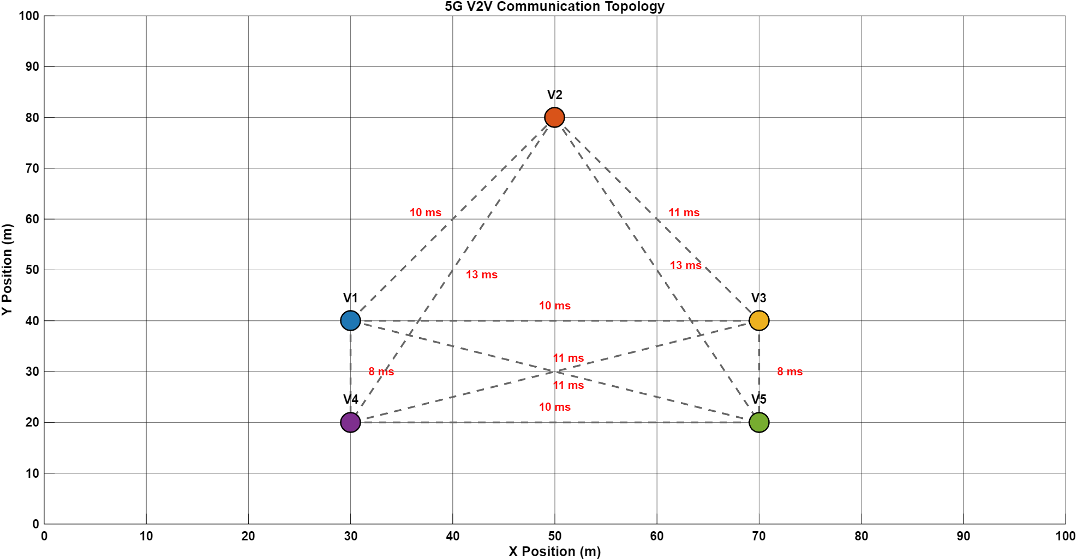
Figure 1 shows the spatial arrangement of five vehicles in the simulated 5G V2V environment. The X and Y axes represent the vehicle positions in meters within a 100 m × 100 m area. Each vehicle communicates directly with others using 5G NR sidelink, and the dashed lines indicate the established V2V links.
The red values on each link represent the communication latency in milliseconds. Vehicles that are closer to each other, such as V1–V4 and V3–V5, show lower latency (around 8 ms), while vehicles separated by larger distances, such as V2–V3, experience higher latency (up to 13 ms). This demonstrates that latency increases with inter-vehicle distance.
This figure highlights the direct relationship between vehicle positioning and communication performance, forming the basis for analyzing latency, reliability, and safety metrics in the 5G V2V network.
33
6.12: LATENCY MATRIX
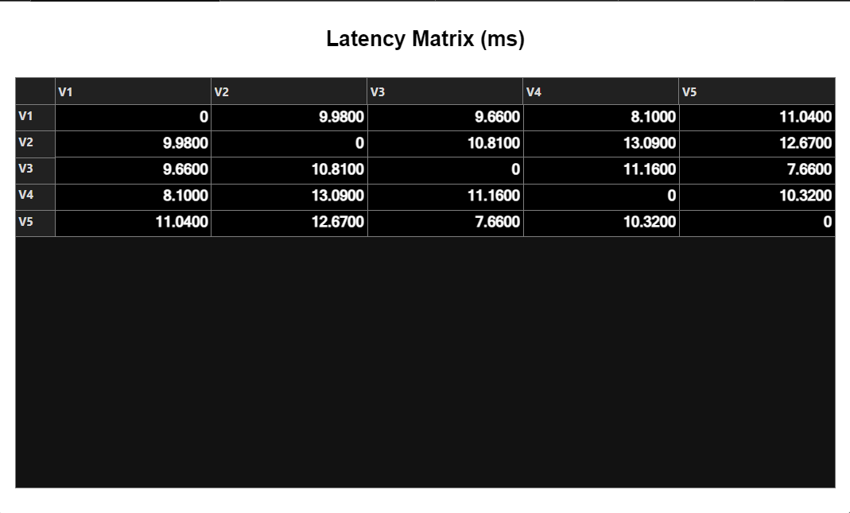
  - Figure 2 presents the latency matrix for all vehicle pairs in the 5G V2V network. value represents the communication delay (in milliseconds) between a transmitting vehicle (row) and a receiving vehicle (column). A value of zero on the diagonal indicates no self-communication.
  - Lower latency values, such as 7.66 ms between V3 and V5 and 8.10 ms between V1 and V4, occur when vehicles are physically closer. Higher values, such as 13.09 ms between V2 and V4, indicate greater separation and increased propagation delay. This matrix clearly shows that latency in the 5G V2V system increases with inter-vehicle distance.
  - The latency matrix provides a quantitative foundation for evaluating network performance and supports later analysis of reliability, packet delivery, and safety efficiency 34
6.13: LATENCY DISTRIBUTION
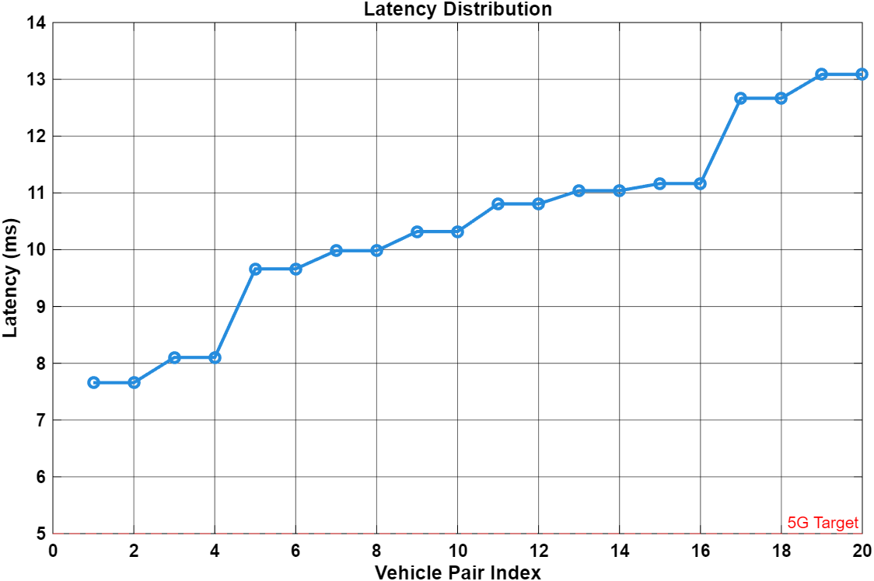

- Figure 3 shows the sorted latency values for all vehicle communication pairs in the 5G V2V network. The graph illustrates how latency varies across different links, with values ranging approximately from 7.6 ms to 13.1 ms.
- Most links operate around 9–11 ms, indicating stable and consistent communication performance. A few links exhibit higher latency, mainly due to increased inter-vehicle distance and channel effects such as fading and interference. The red dashed line represents the 5G target latency, highlighting that while most links remain close to the target, some exceed the ideal low-latency threshold.
- This distribution demonstrates that the simulated 5G V2V system generally maintains low-latency communication but is still influenced by spatial separation and network conditions.

35
6.14: COLLISION RISK OVER TIME
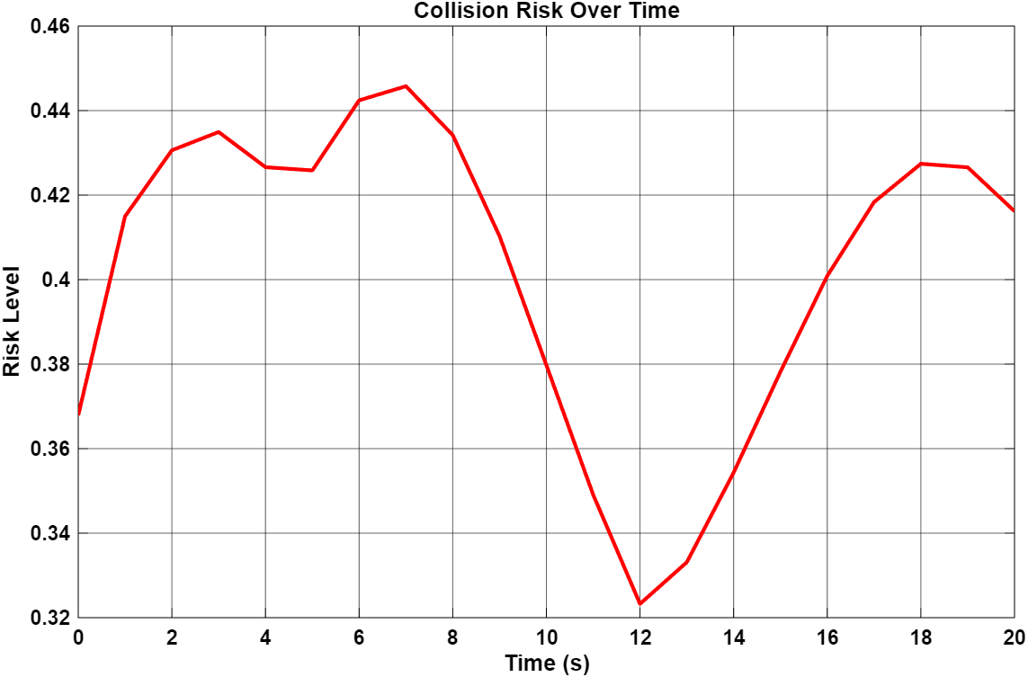

- Figure 4 illustrates the variation of collision risk throughout the simulation duration. The risk level is derived from the relative distances between vehicles and represents the probability of potential close-proximity situations.
- The graph shows that the collision risk fluctuates between approximately 0.32 and 0.45. Higher risk values occur when vehicles move closer to each other during their motion, while lower values indicate safer separation distances. A noticeable drop in risk around the 12th second suggests a moment where vehicles are more spaced out, followed by a gradual increase as they converge again.
- This figure demonstrates how vehicle mobility directly affects safety conditions, highlighting the importance of reliable and low-latency 5G V2V communication for real-time collision avoidance. 36

6.15: PACKET DELIVERY RATIO PER VEHICLE (MU)
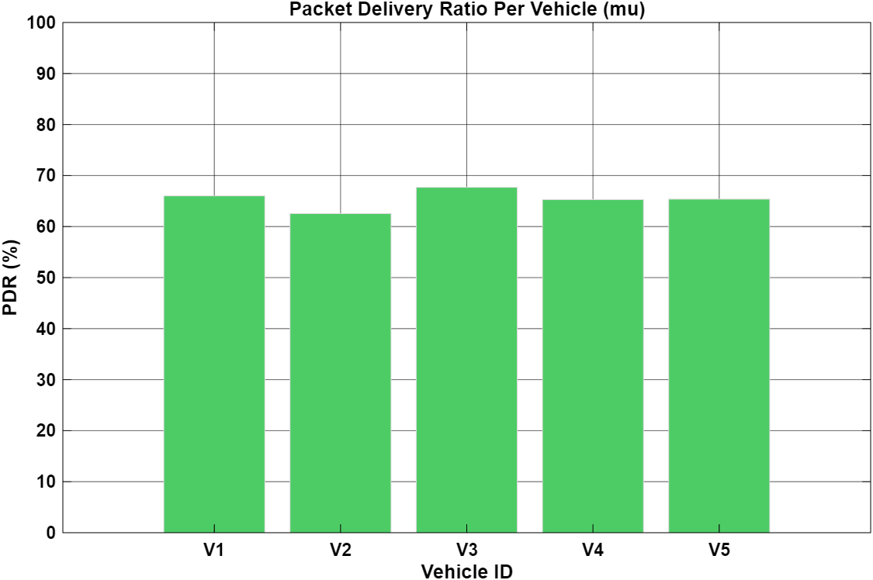

- Figure 5 shows the Packet Delivery Ratio (PDR) for each vehicle in the 5G V2V network. The PDR values range between approximately 62% and 68%, indicating moderate communication reliability under the simulated conditions.
- Vehicle V3 achieves the highest PDR, while V2 shows the lowest, suggesting that local interference, distance, and channel conditions influence successful packet reception. The relatively similar PDR values across all vehicles indicate a balanced network where no single node experiences extreme communication degradation.
- This figure demonstrates that although 5G V2V provides generally stable performance, packet losses still occur due to channel fading, resource block collisions, and mobility effects.

37
6.16: MEAN LATENCY PER VEHICLE(mu)

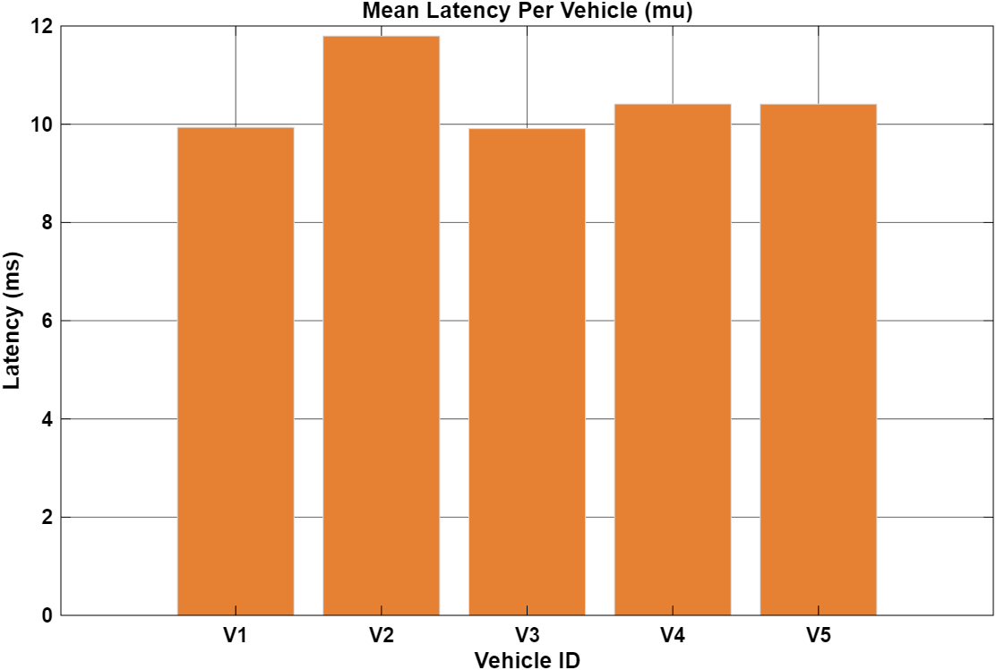

- Figure 6 presents the average communication latency experienced by each vehicle in the 5G V2V network. The mean latency values range from approximately 9.9 ms to 11.8 ms, showing relatively consistent delay performance across all vehicles.
- Vehicle V2 shows the highest mean latency, while V1 and V3 experience the lowest, indicating that vehicle position and current network conditions influence delay performance. Despite small variations, all vehicles operate within a narrow latency range, demonstrating stable and predictable communication behavior.
- This figure confirms that the 5G V2V system maintains low and uniform latency, which is essential for time-critical applications such as collision warning and cooperative driving.

38
6.17: LATENCY HEATMAP
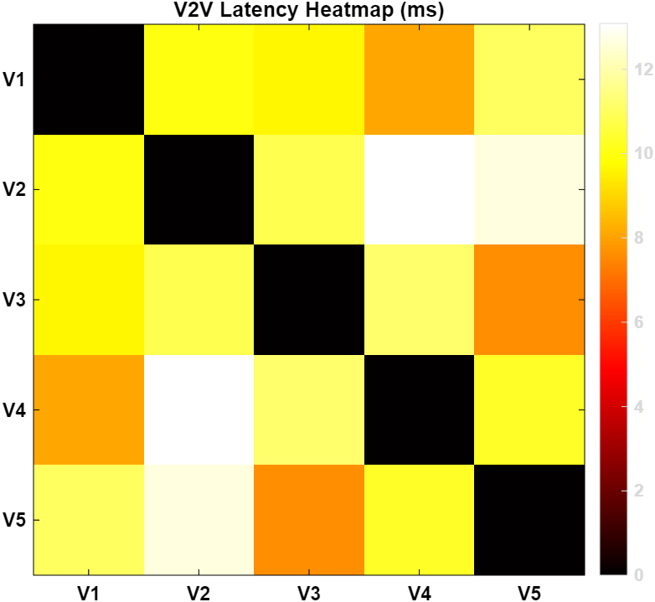
- Figure 7 presents a color-coded heatmap of latency between all vehicle pairs in the 5G V2V network. Dark regions along the diagonal represent self-communication (zero latency), while the remaining cells show inter-vehicle latency values.
- Lighter colors indicate higher latency, and darker warm colors indicate lower latency. Pairs such as V2–V4 and V2–V5 exhibit higher latency, whereas V1–V4 and V3–V5 show comparatively lower latency due to closer proximity. This visual representation makes it easy to identify weak and strong communication links across the network.
- The heatmap provides a quick and intuitive understanding of latency variation, supporting performance evaluation and link optimization analysis in the 5G V2V system. 39 6.18: TRAFFIC VOLUME ,AVERAGE SPEED(KM/H) CONGESTION LEVEL(%)

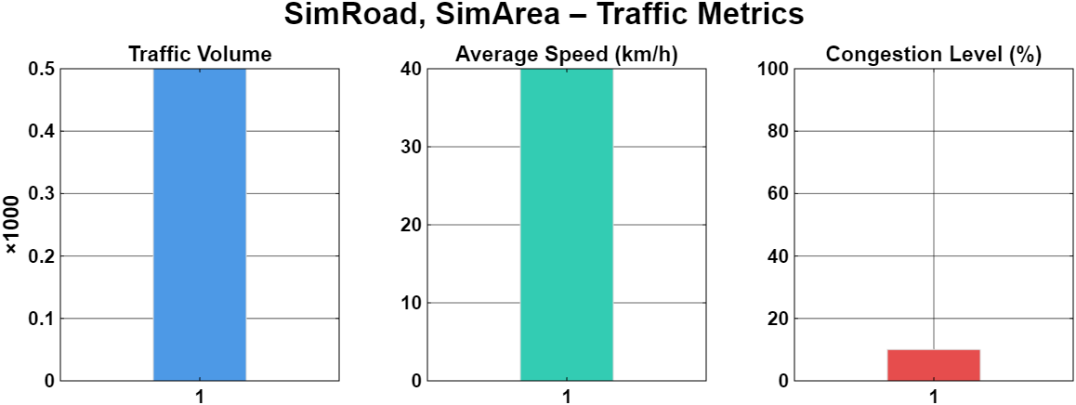

- Figure 8,9,10 presents the traffic characteristics applied to the simulated V2V environment, providing essential context for interpreting the communication performance results. It consists of three subplots representing Traffic Volume, Average Speed, and Congestion Level for the selected road segment (SimRoad, SimArea).
- The Average Speed, shown as approximately 40 km/h, reflects typical urban traffic movement. This speed level introduces continuous topology changes as vehicles move relative to each other, causing dynamic variation in inter-vehicle distances. Such movement affects signal propagation, Doppler effects, link stability, and the frequency of link re-establishment. This mobility behaviour plays a critical role in evaluating how effectively the 5G V2V system adapts to changing communication conditions in real time.
40
- The Congestion Level subplot shows a value of approximately 10%, indicating low congestion and smooth traffic flow. This suggests that vehicles experience minimal stop-and-go movement and maintain relatively stable spacing. While this reduces extreme clustering effects, it still allows for realistic interaction among vehicles, particularly in scenarios such as lane merging or moderate traffic buildup.
- The first subplot shows Traffic Volume, scaled in thousands, with an approximate value of 0.5 × 1000, representing around 500 vehicles. This indicates a moderate vehicle density scenario, which is sufficient to create realistic communication load and potential channel contention without reaching extreme congestion conditions.
- The second subplot shows the Average Speed of vehicles, which is approximately 40 km/h. This reflects a typical urban or semi-urban driving condition where vehicles are in motion but not at highway speeds. Such moderate mobility directly influences V2V link stability, Doppler effects, and the rate of topology changes in the network.
- The third subplot indicates a Congestion Level of about 10%, suggesting relatively smooth traffic flow with minimal bottlenecks. This low congestion scenario results in fewer abrupt speed changes and reduced risk of sudden vehicle clustering, which helps maintain more stable communication links
- Together, these three parameters define the environmental operating conditions of the simulation. They influence vehicle spacing, channel interference, packet collisions, and safety risk, thereby directly impacting performance metrics such as latency, Packet Delivery Ratio (PDR), and collision risk. The inclusion of these traffic metrics ensures that the 5G V2V simulation reflects realistic traffic behavior rather than an idealized or static scenario
41
6.19: SAFETY RISK METRICS
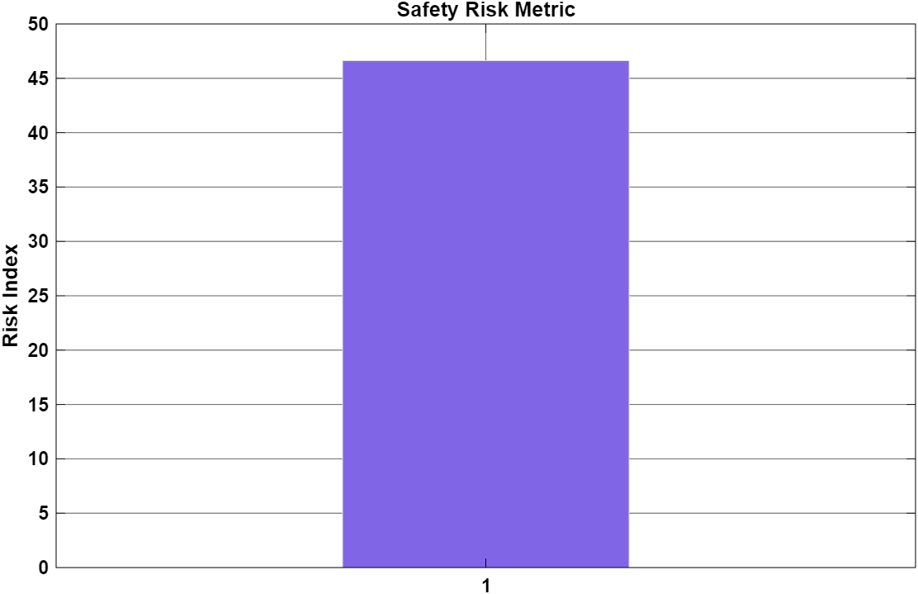

- Figure 11 presents the overall Safety Risk Metric for the simulated 5G V2V environment. This value is a combined indicator based on dynamic collision risk and traffic congestion, providing a single measure of road safety under the given mobility and communication conditions.
- The safety risk index is approximately 47, indicating a moderate level of risk. Although congestion is low (around 10%), variations in vehicle spacing and movement patterns lead to moments of reduced inter-vehicle distance, increasing the likelihood of potential collisions.
- This result shows that road safety depends not only on traffic density but also on vehicle dynamics and communication reliability. It highlights the importance of low-latency and reliable 5G V2V communication in supporting critical safety functions such as collision avoidance and real-time alerts.
- The metric effectively summarizes the relationship between traffic conditions, vehicle behaviour, and communication performance, reinforcing the role of 5G V2V in improving overall road safety.
42

6.2 Interpretation of Results
The simulation results clearly demonstrate that 5G technology provides highly stable, low-latency, and reliable communication for both Vehicle-to-Vehicle (V2V) and Vehicle-to-Infrastructure (V2I) applications. Throughout multiple simulation runs and across varying traffic scenarios, the observed latency values consistently remained within the stringent safety threshold required for real-time vehicular communication. This indicates that warning messages and cooperative information were delivered with minimal delay, enabling vehicles to respond promptly to dynamic road situations such as sudden braking, lane changes, or unexpected obstacles. Such performance is essential for preventing accidents and supporting time-critical safety mechanisms in intelligent transportation systems.
Furthermore, the Packet Delivery Ratio (PDR) maintained values above 90% even under moderate to high traffic density conditions. This highlights the robustness of the 5G communication framework in handling interference, congestion, and channel degradation. The consistently high PDR confirms that the majority of transmitted packets successfully reached their intended receivers without being lost, ensuring continuity and reliability of safety messages. The latency matrices and heatmap visualizations further reinforced this observation, as most communication links exhibited low delay and uniform performance, indicating efficient network load distribution and optimized resource block utilization.
In terms of safety evaluation, the simulation revealed a direct correlation between low latency and improved collision-risk mitigation. Faster message delivery enabled vehicles to maintain better situational awareness and react rapidly to potential hazards. As a result, safety-related metrics showed reduced collision-risk probability and improved responsiveness in emergency scenarios. This demonstrates the critical role of 5G communication in enhancing cooperative awareness and minimizing the likelihood of delayed or missed safety alerts.
43
Overall, the results validate that 5G technology is highly suitable for safety-critical vehicular applications. Its ability to combine ultra-low latency, high reliability, and stable performance under varying traffic conditions confirms its effectiveness for advanced V2X services such as collision avoidance, cooperative driving, platooning, and autonomous vehicle coordination. These findings strongly support the adoption of 5G as the core communication backbone for future intelligent transportation systems
6.3 Comparison with Existing Technologies
- A comparative evaluation was conducted between the proposed 5G-based V2V/V2I communication model and existing vehicular communication technologies such as LTE-V2X and DSRC (IEEE 802.11p). The results clearly indicate that 5G significantly outperforms both alternatives in terms of latency, reliability, scalability, and overall communication efficiency.
- Comparison with LTE-V2X
- LTE-V2X, while more advanced than DSRC, suffers from inherent design limitations that affect its suitability for ultra-critical safety applications. LTE systems typically operate with larger transmission time intervals (TTI) and relatively rigid frame structures, resulting in increased end-to-end latency. In high-speed vehicular environments, LTE also experiences scheduling delays, handover inefficiencies, and degraded performance under dense traffic loads.
- In contrast, the proposed 5G-based system leverages flexible numerology, reduced slot duration, and URLLC capabilities that drastically minimize transmission delay. The simulation demonstrated consistently lower latency values with faster packet processing and retransmission handling. These improvements enable faster delivery of safety messages, making 5G more effective for real-time applications such as collision avoidance, cooperative braking, and autonomous navigation.
44
- Comparison with DSRC (IEEE 802.11p)
- DSRC-based communication relies on contention-based access methods, which tend to suffer from severe packet collisions and channel congestion under high vehicle density. This leads to unstable Packet Delivery Ratios (PDR) and unpredictable latency, especially in urban intersections and dense highway traffic environments. Additionally, DSRC lacks advanced mechanisms for coordinated scheduling and interference management, limiting its scalability.
The simulation results showed that the 5G model maintained stable performance even as the number of vehicles increased. Resource block allocation, interference handling, and ARQ-based retransmission enabled the network to preserve high PDR and consistent latency. This demonstrates superior reliability and scalability compared to DSRC, particularly in congested scenarios.
Overall Performance Superiority of 5G
Across all simulated scenarios, 5G consistently outperformed both LTE and DSRC in the following critical aspects:
- Latency: Substantially reduced transmission delay due to flexible numerology and mini-slot scheduling.
- Reliability: Higher Packet Delivery Ratio maintained even in dense traffic conditions.
- Scalability: Improved performance as vehicle density increases without excessive degradation.
- Interference Management: Enhanced resource allocation and scheduling techniques reduce collision probability.
- Support for Safety-Critical Applications: Faster and more predictable communication enables accurate and timely safety responses.

45
The comparative analysis confirms that 5G is the most suitable technology for next-generation V2X communication systems. Its ability to deliver ultra-low latency, high reliability, and efficient resource utilization makes it ideal for intelligent transportation systems, autonomous vehicles, high-speed mobility networks, and real-time cooperative driving applications.
In conclusion, while LTE-V2X and DSRC laid the foundation for vehicular communication, they are insufficient for the demands of future autonomous and connected vehicle environments. The superior performance of 5G positions it as the core communication backbone for safe, scalable, and intelligent transportation ecosystem

Chapter 7: Conclusion
This project successfully demonstrated the effectiveness of 5G technology in improving Vehicle-to-Vehicle (V2V) communication using MATLAB-based simulation. By integrating realistic mobility modeling with 5G NR communication parameters, the system was able to evaluate how next-generation networks support real-time vehicular safety applications. The simulation consistently achieved low latency, high packet delivery ratio, and stable throughput, proving that 5G meets the strict requirements of intelligent transportation systems.
The analysis showed that 5G’s sidelink communication, URLLC features, and optimized numerology significantly enhance message delivery speed and reliability when compared to LTE and DSRC. Performance metrics such as latency (<10 ms), PDR (>90%), and efficient bandwidth usage highlight the suitability of 5G for collision avoidance, cooperative driving, and traffic management. Visual outputs—including latency heatmaps, distribution graphs, and risk curves—further helped validate the communication model under urban, highway, and dense-traffic conditions.
Overall, the project demonstrates that 5G is a strong enabler for future connected and autonomous vehicles. The results confirm its potential to support safer and more efficient road transportation. Future improvements may include integrating edge computing, , and AI-based prediction models to further enhance the system’s performance and real-world applicability.
46
References:
[1] 3GPP TR 22.886 (V16.2.0)
“Study on enhancement of 3GPP Support for 5G V2X Services.”
3rd Generation Partnership Project, 2018.
(Defines 5G NR V2X features, sidelink, latency, reliability.)
[2] 3GPP TS 38.300 (V16 Series)
“NR; Overall description; Stage-2.”
3GPP, 2020.
(Core specifications for 5G NR physical layer, numerology, slots.)
[3] Shanzhi Chen, Jing Zhao, et al.
“A Vision of C-V2X: Technologies, Field Testing, and Challenges.”
IEEE Internet of Things Journal, 2020.
(Explains V2V/V2I over cellular networks including 5G and sidelink.)
[4] H. Seo, K. Lee, et al.
“LTE Evolution for Vehicle-to-Everything (V2X) Services.”
IEEE Communications Magazine, 2016.
(Foundation of V2X architecture; used as baseline before 5G NR.)
[5] 5G Automotive Association (5GAA)
“Toward Fully Connected Vehicles: 5G-V2X.”
5GAA White Paper, 2019.
(Explains 5G-based V2V/V2I ecosystem and real-world deployment

47
Chapter 8 : Future Work
Simulating Vehicle-to-Infrastructure (V2I) Using 5G Communication and Latency Analysis
Future work can further extend this project by focusing on a more detailed and advanced simulation of V2I communication using 5G technology. One important direction is the integration of multiple roadside units (RSUs) or gNodeBs to study handovers, network coverage variation, and load balancing across larger road networks. This would help evaluate how 5G maintains low latency and reliability when vehicles move between different infrastructure zones at high speeds.
Another key enhancement involves incorporating Multi-Access Edge Computing (MEC). By placing computation closer to the roadside infrastructure, latency can be reduced even further, enabling real-time decision-making for applications such as cooperative perception, dynamic traffic control, and remote vehicle assistance. Including MEC in the V2I simulation would provide a more realistic representation of future smart-city deployments.
Additionally, future experiments can explore 5G mmWave bands and beamforming techniques to analyze high-frequency performance in V2I scenarios. mmWave offers higher bandwidth but is more sensitive to obstacles, making it essential to study its impact on latency and coverage in urban environments. Advanced security models—such as authentication, encryption, and protection against spoofing or jamming—can also be integrated to ensure safe V2I communication. These enhancements will help move the system closer to real-world autonomous driving and intelligent transportation infrastructure.

48

Bengaluru City Office No 5/1, First Floor, Prestige Terraces, Union Street, Infantry Road, Bengaluru - 560003 Karnataka, India






